**Hashtag EVO2016**

As EVO grows every year, its Twitter presence grows. You can expect to see #EVO20XX rending every year during the three-day tournament. Now that the tournament has ended, I decided to look back at some of the highlights via Twitter. Using R, a programming language and software environment for statistical computing and graphics and the *twitteR* package I was able to access Twitter’s web API allowing me to do things like download tweets, look at the metadata (screen name, retweet count, date created, etc.) and use R to perform statistical analyses with the data.

I assume the majority of people reading this are more care more about fighting game and social media than programming so I won’t waste time showing the code here. Instead, I’ll make a separate write up all about how I did this and the problems I encountered. Without further ado, let’s look at some tweets!

**Volume of Tweets**

Unfortunately, I was not able to get Friday’s tweets. Without going into too much detail, I took too long to get it to work. Fortunately, I Saturday and Sunday worked out just fine and I was still able to find out the total number of Tweets from Friday. There were many more tweets the following day, but I had to make a cutoff point somewhere. Saturday and Sunday provided more than enough data to work with anyway.

* Friday: 21,589 tweets
* Saturday: 39,234 tweets
* Sunday: 76,350 tweets
* Total: 137,173 tweets

The metadata includes a timestamp for each tweet. With this, I made a histogram showing the times when people were tweeting the most.

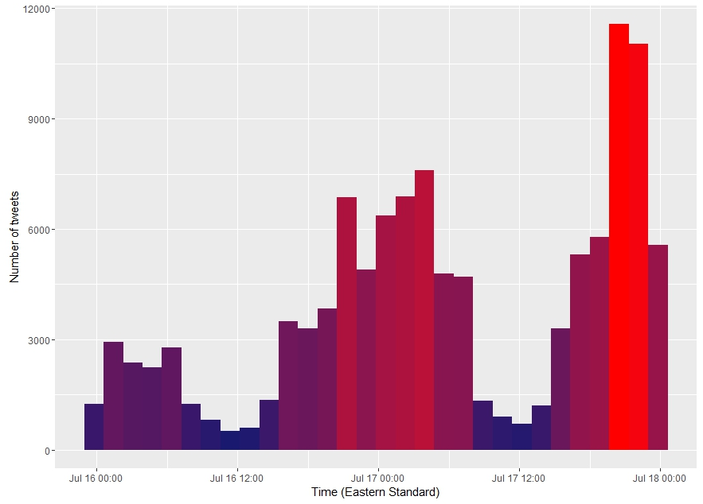

**Wordcloud**

A word cloud is a graph representing words that are most commonly used in a group of text. The words can scale in size, position, and color based on their usage or be randomized in any of those categories. You can simply think of it as a fancy picture showing what people were talking about the most. I ran into some complications because 100,000 tweets produced a ton of unique words (and some garbage as result of cleaning the data). Still, the word cloud came out nice enough to work with. I apologize if it’s too small to read. Resizing it was a nightmare.

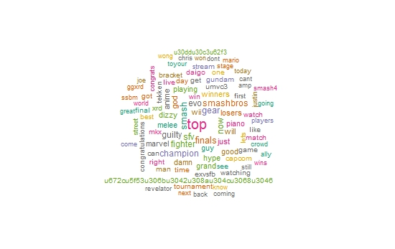

Some notable words

* “Joe”: LI Joe who was a fan favorite for his performance in Street Fighter V.
* “Chris”: ChrisG finally winning Marvel.
* “Wong”: Justin Wong.
* “Daigo”: Daigo Umehara.
* “Ally” and “Mario”: Winner of Super Smash Bros WiiU and his character.
* “dizzy”: I think this is a character in Guilty Gear Xrd, but I don’t play that game so I’m not sure what its referring to.
* “hype”: What better word to describe EVO.

**Most Tweets**

These are the top eight people who tweeted the most during throughout EVO. If you don’t know what I chose the number eight, then you don’t play fighting games.

1. **EMITSUA** 349 Tweets
2. **RobertPixelania** 311 Tweets
3. **Pixelania** 309 Tweets
4. **Aeriqui** 290 Tweets
5. **Kombatjennings** 287 Tweets
6. **momoi_mine** 237 Tweets
7. **rokuma_G** 235 Tweets
8. **absently** 225 Tweets

**Most favorited Tweets**

These are the eight tweets that received the most favorites.

**NintendoAmerica:** 4405 Favorites

Congratulations to @allyornotally, your #SmashBros for Wii U #EVO2016 Champion! https://t.co/dUjEwOw2Ac

**MowtenDoo:** 4292 Favorites

THIS GUY IS PLAYING ANIME FIGHTER WITH A GOD DAMN PIANO #Evo2016 <https://t.co/4Bhe7XPAXf>

**PR_Balrog:** 2288 Favorites

Not upset nor happy about my performance.\nGgs everyone and remember only 1 can win.\n\nThanks for cheering!\n\n#Evo2016 https://t.co/9ojSyNGfdM

**ESPN_Esports:** 2015 Favorites

.@daigothebeast has a brief message for @JWonggg \n\n#Evo2016 https://t.co/8gv7AINkSZ

**NintendoAmerica:** 1806 Favorites

The best #SmashBros Melee players in the world are competing now in the #EVO2016 Finals! https://t.co/RivFdqA0Rj https://t.co/nHtWt2zGbX

**NintendoAmerica:** 1795 Favorites

It’s all come down to this. The #EVO2016 #SmashBros for Wii U Top 32 has begun! https://t.co/q356rndXq9 https://t.co/bgODtwOImC

**Wario64:** 1403 Favorites

Dizzy in Guilty Gear #EVO2016 https://t.co/6yvE6wLcqj

**Most retweeted Tweet**

MowtenDoo tweeted a picture of someone using a piano as his controller which was retweeted 2908 times.

“THIS GUY IS PLAYING ANIME FIGHTER WITH A GOD DAMN PIANO #Evo2016 <https://t.co/4Bhe7XPAXf>”

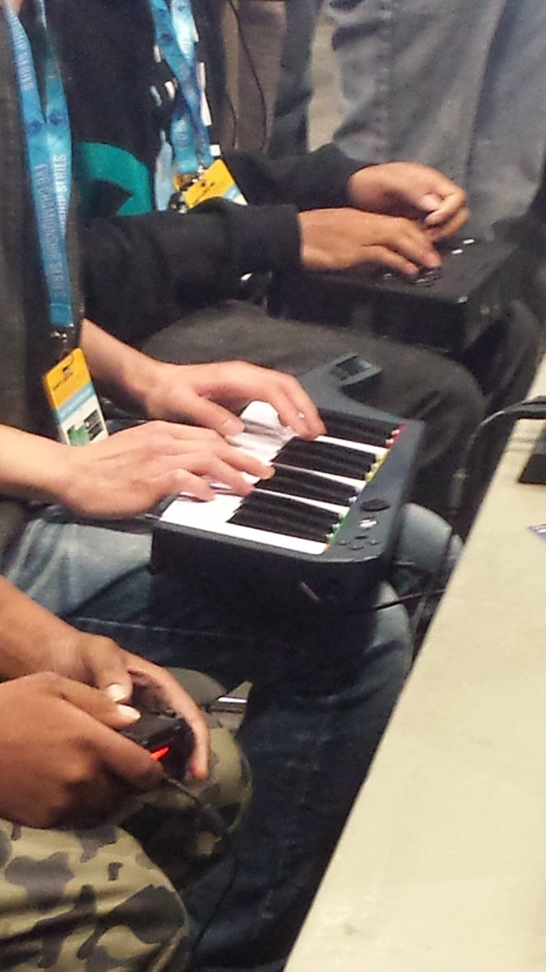

That’s all I have to show for EVO 2016 on Twitter. If you have any ideas or suggestions for what I can do next year, you can tweet me [@Don_Meka](https://twitter.com/Don_Meka). I appreciate you taking the time to read this.